**PROJECT WORK**

**COMPREHENSIVE**

**DIGITAL MARKETING FOR PTRON**

SHAIK SUFIYA

VASAVI MAHILA KALASALA

22231014042

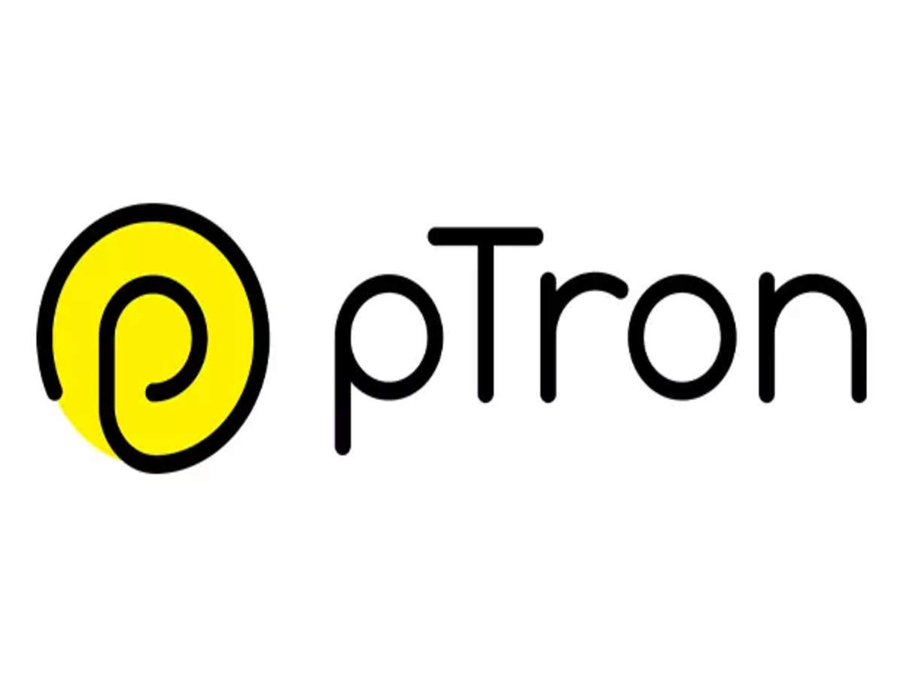pTron was conceptualized as an electronic and mobile accessories company. In the year 2014, pTron started manufacturing mobile accessories through contract manufacturers in China. pTron.in is a brand owned by Palred Electronics Private Limited., which is a subsidiary of Palred Technologies Ltd, a public-listed company on BSE and NSE since 2004.  
  
The brand pTron offers a bouquet of mobile accessories products to meet the needs of its consumers. pTron sells products like Bluetooth headsets, portable Bluetooth speakers, wired headsets, chargers and cables, smart watches, networking products and many more.  
  
The strength of pTron is that it has a wide range of products whose quality is backed by warranty, but offers them at competitive prices in the branded accessories category for the mid-market.  
  
pTron has successfully delivered over 5 million products (mobile accessories like Bluetooth earphones, smart watches, Bluetooth speakers etc) to valued customers over multiple online platforms as well as offline distribution and retail channels in India. After establishing a strong and wide consumer base online successfully, pTron entered the offline market in India. It presently has 40 distributors covering 12 states in India. Based on SKUs and the number of units sold pTron has emerged as the largest Indian mobile accessories company. It now competes with established large multinational brands in India.  
  
Subsequent to establishing itself as a trusted mobile accessories brand in India, pTron has now expanded its business in the global markets and has set up distribution channels in countries like USA, Hong Kong, Israel, Indonesia etc.

**BRAND STUDY COMPETITORS ANALYSIS &BUYER’S/AUDIENCE’S PERSONA**

1.Brand Study:

* **Ownership and History:** pT ron is a brand owned by Palred Electronics Private Limited, a subsidiary of Palred Technologies Ltd, a public-listed company on BSE and NSE since 2004.
* **Founder and CEO:** Ameen Khwaja is the Founder and CEO of pTron.
* **Brand Identity:** pTron has a new brand identity with a redesigned logo and packaging, aiming to evoke inspiration and modernness, reflecting its position as a young and enthusiastic brand.
* **Product Range:** pTron offers a range of products including Bluetooth headsets, portable Bluetooth speakers, wired headsets, chargers and cables, smartwatches, and networking products.
* **Target Audience:** pTron aims to cater to the youth in major cities of India, offering technology across various income classes.

2.Competitors Ananlysis:

PTron, a leading Indian mobile accessories brand, faces competition from established multinational brands and emerging domestic players, including Xiaomi, Nothing, and boAt Lifestyle.

Here's a more detailed look at PTron's competitive landscape:

Key Competitors:

* + **boAt Lifestyle:**

A prominent player in the Indian audio and smart wearable market, known for its focus on design and lifestyle products.

* + **Noise:**

Another strong competitor in the smart wearable and audio accessories space, particularly known for its fitness trackers and smartwatches.

* + **Mivi:**

A relatively newer brand that has gained traction in the true wireless earbuds market, particularly at the entry-level price point.

* + **Xiaomi:**

A global technology giant with a strong presence in the Indian market, offering a wide range of mobile accessories and smart devices.

3. Buyer’s Audience’s Persona :

Identify the target audience’s demographics,needs,goals and points

Create a detailed persona profile, including:

1. Name and bio
2. Age ,occupation and education
3. Goals,Challenges and motivations
4. Prefered communication and channels and behaviours
5. Buying habits and decisions making process

Determine the persona’s information needs and preferred content formats

Develop a deep understanding of the persona’s needs and preferences to inform marketing strategies and content creation.

**SEO & KEYWORD REASERCH**

1. Understanding Ptron's Products and Target Audience:

* **Product Categories:**

Identify the main product categories Ptron offers (e.g., power banks, headphones, speakers, mobile accessories).

* **Target Audience:**

Consider who Ptron's products are aimed at (e.g., students, tech-savvy individuals, budget-conscious consumers).

* **Search Intent:**

Determine what users are looking for when searching for these products (e.g., "best power bank under ₹1000," "noise-canceling headphones for travel").

2. Keyword Research :

* **Competitor Analysis:**

Analyze the keywords that Ptron's competitors are targeting.

* **Keyword Intent:**

Ensure that the keywords align with the search intent of the target audience.

1. Examples of Keywords for Ptron:

* **Power Banks:**
  + "best power bank for iphone"
  + "portable power bank"
  + "power bank 20000mah"
  + "power bank with fast charging"
  + "power bank under ₹1000"
* **Headphones:**
  + "wireless headphones"
  + "noise cancelling headphones"
  + "bluetooth headphones"
  + "headphones for gaming"
  + "headphones with long battery life"
* **Speakers:**
  + "portable bluetooth speaker"
  + "wireless speaker"
  + "speaker with subwoofer"
  + "speaker for outdoor"
  + "speaker with long battery life"
* **Mobile Accessories:**
  + "mobile phone stand"
  + "mobile phone charger"
  + "mobile phone case"
  + "mobile phone screen protector"
  + "mobile phone tempered glass"

5. SEO Optimization:

* **On-Page Optimization:**

Optimize website content with relevant keywords, meta descriptions, and alt tags.

* **Off-Page Optimization:**

Build high-quality backlinks to improve website authority.

* **Content Marketing:**

Create valuable content that addresses the needs and interests of the target audience.

* **Regular Updates:**
* Continuously monitor and update keyword strategy based on search trends and user behavior.

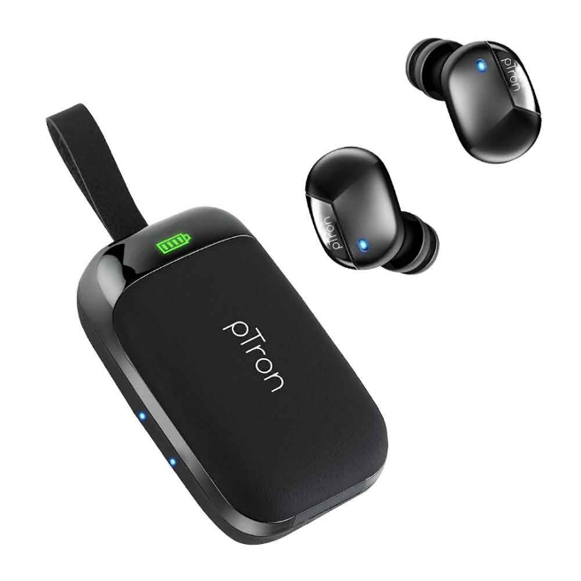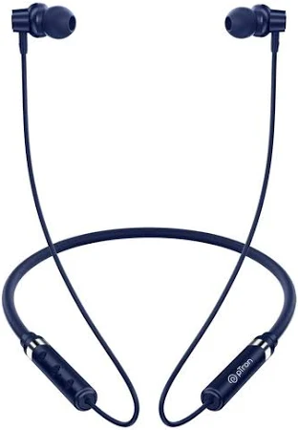

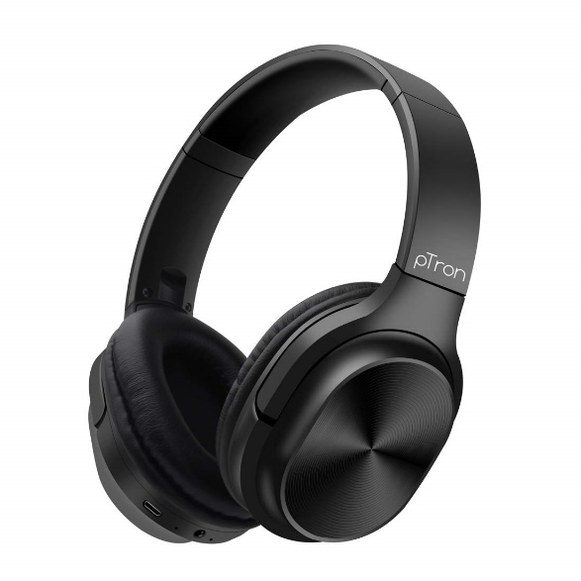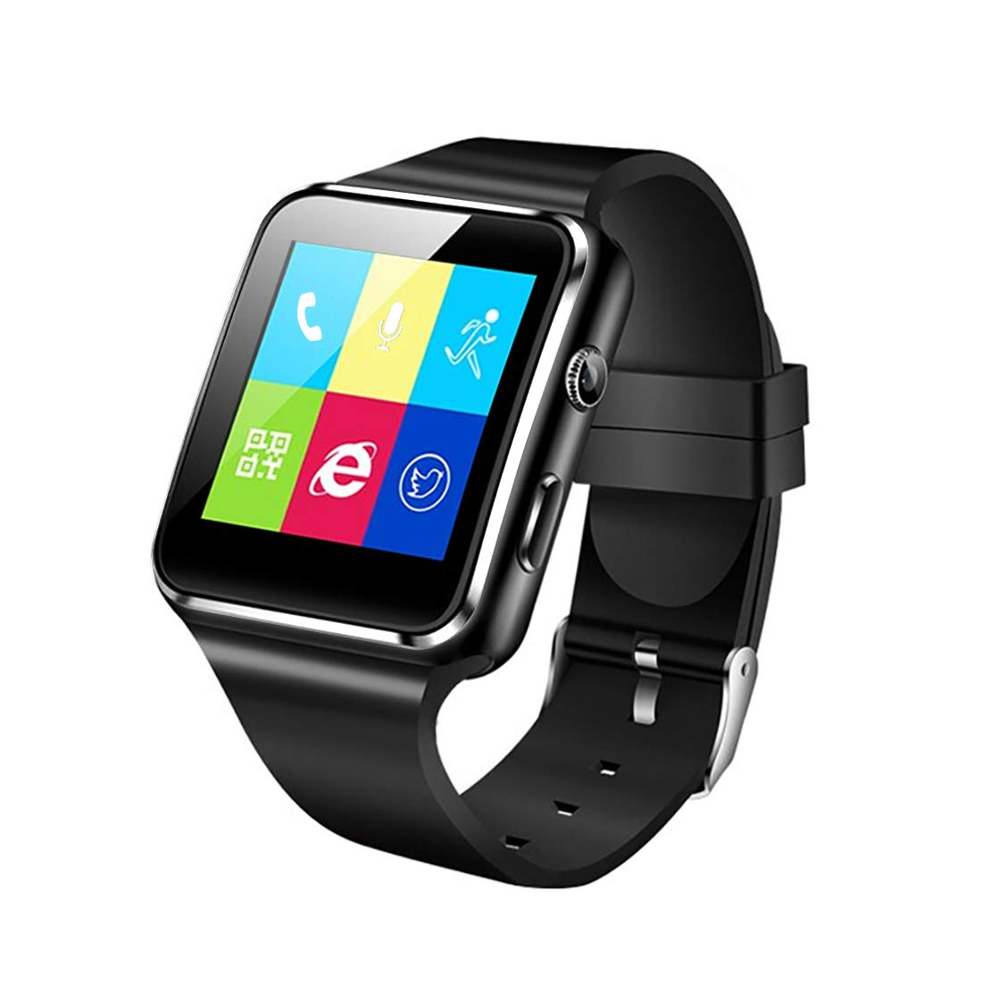

pTron is a brand known for its affordable and stylish consumer electronics, including audio accessories, smartwatches, and mobile accessories. Here are some content ideas and marketing strategies to boost brand awareness and sales.

---

**Content Ideas for pTron Products**

**1. Engaging Social Media Content**

Unboxing & First Impressions: Partner with micro-influencers to showcase new launches.

Product Comparisons: Highlight how pTron products stack up against competitors in terms of price, features, and durability.

How-to Guides & Tutorials: Explain how to use features like Bluetooth pairing, touch controls, or noise cancellation effectively.

User-Generated Content (UGC): Encourage customers to share their experiences using a branded hashtag (#pTronVibes).

2. Video Marketing

Short Reels & TikToks: Create trendy, fast-paced videos showing lifestyle use cases.

Behind-the-Scenes (BTS): Show the manufacturing, quality testing, or design process.

Customer Testimonials: Feature happy users talking about their experience with pTron.

**3. Blog & SEO Content**

Best Budget Wireless Earbuds Under ₹1,000 (Including pTron models)

How to Choose the Right Smartwatch for Your Needs

Wireless Earphones vs. Wired – Which One is Best for You?

**4. Influencer & Affiliate Marketing**

Collaborate with tech YouTubers & Instagram influencers for honest product reviews.

Run affiliate marketing campaigns to increase reach through tech bloggers.

**5. Seasonal & Event-Based Campaigns**

Festival Bundles & Offers (Diwali, Christmas, etc.)

Back-to-School Deals (Affordable audio gadgets for students)

Gaming Gear Launch (Highlight low-latency earbuds for gamers)

---

**Marketing Strategies for pTron**

**1. Digital Marketing Strategies**

SEO & SEM: Optimize product pages and run Google Ads for keywords like "best budget earbuds in India."

Social Media Ads: Target users on Instagram, Facebook, and YouTube with engaging product videos.

WhatsApp Marketing: Send exclusive deals and launch updates to engaged customers.

**2. E-commerce & Marketplace Promotions**

Run Amazon Lightning Deals and Flipkart Big Billion Days Discounts.

Partner with local online stores to enhance brand visibility.

Optimize product listings with high-quality images and detailed descriptions.

**3. Referral & Loyalty Programs**

Offer discounts for referrals (e.g., "Refer a friend and get 10% off").

Launch a loyalty program where frequent buyers earn points for future purchases.

**4. Offline Presence & Experiential Marketing**

Host in-store product demo days at electronics retailers.

Set up pop-up booths at tech fairs & college fests for direct engagement

**1. Content Creation Strategy**

**A. Product Showcasing**

Unboxing & First Impressions – Short videos showcasing packaging and first looks.

Feature Highlights – Posts or reels focusing on key features like battery life, sound quality, and design.

Comparisons – Compare PTron products with competitors or previous versions.

User Testimonials – Share customer reviews and feedback through video clips or carousel posts.

**B. Lifestyle & Use Cases**

Daily Life Integration – Show how PTron earbuds, smartwatches, and accessories fit into daily life.

Fitness & Workout – Content featuring gym-goers using PTron wireless earbuds or smartwatches.

Travel-Friendly Tech – Highlight products’ portability, battery life, and durability.

**C. Interactive & Engaging Content**

Polls & Quizzes – "Which PTron earbud suits your style?"

Giveaways & Contests – Encourage user participation by offering freebies.

Behind-the-Scenes – Factory production insights, team introductions, or upcoming product teasers.

**D. Educational & Value-Added Content**

Tech Tips & How-To Guides – E.g., “How to reset your PTron Bluetooth earbuds” or “Best equalizer settings for PTron headphones.”

FAQs & Troubleshooting – Address common customer queries in videos, infographics, or posts.

**2. Content Curation Strategy**

Repost UGC (User-Generated Content) – Feature customer photos, unboxing videos, and reviews.

Industry News & Trends – Share tech news, market trends, or comparisons with latest innovations.

Influencer Collaborations – Partner with micro-influencers for unbiased reviews and promotions.

Customer Stories – Highlight real-world experiences from satisfied customers.

**3. Platforms & Formats**

Instagram & Facebook – Reels, carousels, live sessions.

YouTube – Product reviews, comparisons, and tutorials.

Twitter & LinkedIn – Industry news, customer stories, and product launches.

E-commerce Listings (Amazon, Flipkart, etc.) – Optimize descriptions with SEO-friendly content and high-quality images/videos.

**Social Media Marketing Strategy for PTron Products**

**1. Target Audience Analysis**

Tech Enthusiasts – People who love affordable gadgets and accessories.

Fitness & Outdoor Enthusiasts – Users looking for wireless and durable audio products.

Gamers – Those who want low-latency gaming earbuds/headphones.

Students & Young Professionals – Budget-conscious buyers seeking value-for-money accessories.

**2. Platform-Specific Strategies**

A. Instagram & Facebook (Visual & Engagement-Driven Platforms)

Reels & Stories – Short videos showcasing product features, use cases, and testimonials.

Carousel Ads – Multiple images showing different product angles, features, and benefits.

Influencer & UGC Collaboration – Partner with micro-influencers for authentic reviews.

Shoppable Posts – Direct product links for instant purchase.

Polls & Contests – Boost engagement with quizzes and giveaways.

B. YouTube (Long-Form & Influencer Marketing)

Product Reviews & Comparisons – Partner with tech YouTubers for in-depth analysis.

How-To Guides & Troubleshooting Videos – Help users understand and fix common issues.

Shorts (YouTube’s TikTok Alternative) – Quick feature demos or funny product-related content.

C. Twitter (Trending & Community Building)

Product Launch Announcements – Use hashtags like #NewLaunch #PTronAudio.

Tech Tips & Hacks – Share quick insights about maximizing product use.

Engage with Trends – Participate in viral conversations with a tech twist.

D. LinkedIn (Brand Authority & B2B Sales)

Company Updates – Share product innovation stories and milestones.

Case Studies & Success Stories – Feature how PTron is disrupting the budget tech market.

Industry Collaborations – Engage with distributors, partners, and retail chains.

E. TikTok & Snapchat (Gen-Z & Viral Content)

Challenges & Trends – Create viral challenges using PTron products.

Behind-the-Scenes – Quick factory or product development sneak peeks.

**3. Paid Ad Strategy**

**A. Facebook & Instagram Ads**

Targeting:

Age: 18-35 (Budget-conscious tech users)

Interests: Tech gadgets, gaming, fitness, music, e-commerce buyers

Lookalike Audiences: People similar to past customers

Ad Formats:

Video Ads – Engaging 15-30 sec clips highlighting features

Carousel Ads – Showcasing different product models and benefits

Retargeting Ads – Re-engage website visitors or cart abandoners

**B. Google Ads (YouTube & Search Ads)**

YouTube Ads: Run short 6-15 sec non-skippable ads before tech/gaming videos.

Search Ads: Target keywords like “best budget wireless earbuds” or “affordable smartwatches.”

**C. Twitter & LinkedIn Ads**

Promoted Tweets – Feature product deals and discounts.

Sponsored LinkedIn Posts – Target B2B partners, resellers, and distributors.

**4. Engagement & Community Building**

Exclusive Offers for Followers – Special discounts for engaged users.

Live Q&A Sessions – Answer customer queries in real-time.

Customer Stories & Testimonials – Feature real users enjoying PTron products.

**5. Performance Tracking & Optimization**

Use Meta Pixel & Google Analytics to track user behavior.

A/B test different ad creatives, headlines, and CTAs.

Adjust budget based on ROI and conversion rates.

